Airline safety

**Is Air travel safe?**

During the pandemic, people have found a lot of free time in analyzing and looking at various aspects differently. In the past, there have been flight accidents and crashes but the public did not take time from their busy schedule to find the statistics. But now after research, they think flights are riskier to travel. Along with the current situation of the pandemic, the cost of the flight, this is an additional point to avoid the crowd, be safe both from the virus and the travel mishaps and go on a road trip.As per the data and analysis, Flights are still the safest options of travel. Continue reading and I will explain the various facts based on the US data along with few statistics around the globe.

Can you imagine the amount of training you need to go through to get a flying license? Compared to that, the driving license hours are negligible. On average, flying requires 1500 hours of training. Only 45 hours is sufficient for a car.

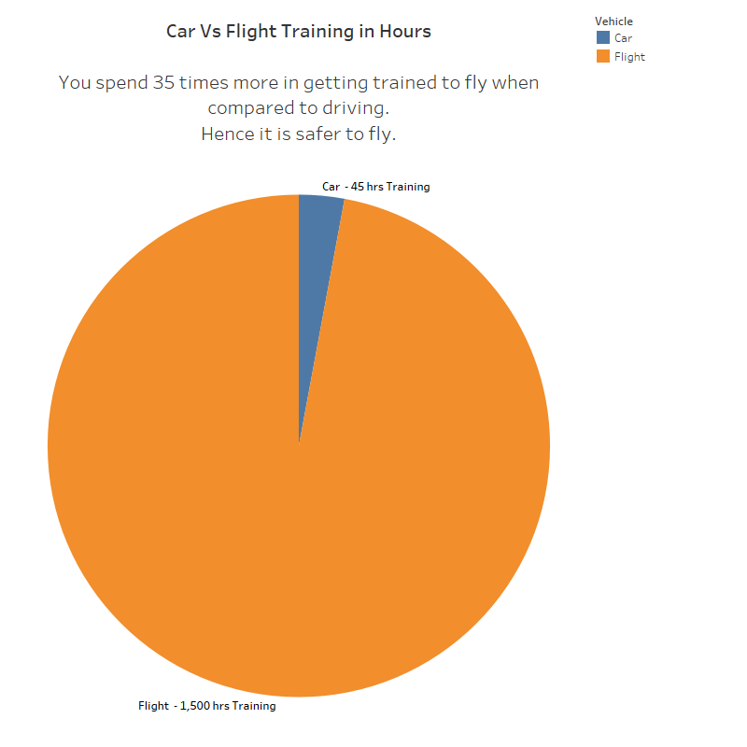

Also, the number of fatalities that occurred from 2000-2014 is high by car. The fatalities by flight are relatively low. There were 576,546 fatalities by car and 687 fatalities by flight. Hence when you compare the flight and the car, no doubt flight would be the safest. Passengers would be more comfortable going on a flight rather than a car.

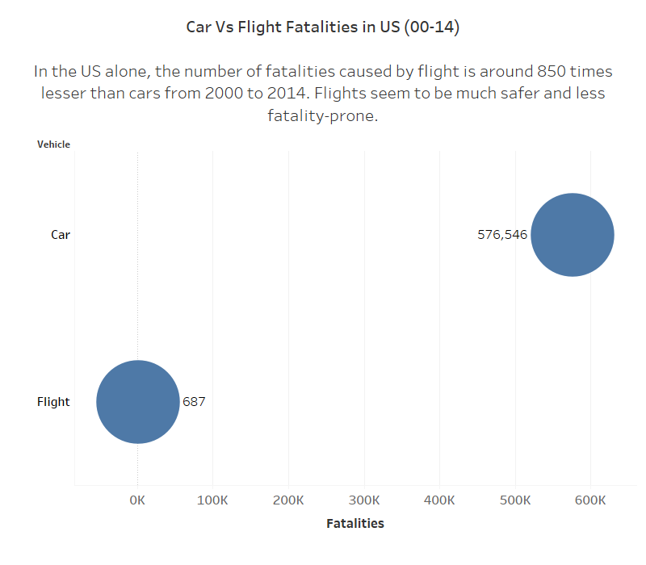

Not only cars, but death by other modes of transport have also been higher. Below you will notice, flights and buses have the least deaths. Motorcycles have the highest deaths per one billion passenger miles. You get additional instructions to follow on a flight in case of an emergency. You would not have heard about self precautionary steps in any other vehicle.

It is better to avoid the last two years for any kind of analysis as regular activities did not occur. Travels were cut down and passengers were reduced. People opted for alternative options.

If we compared the fatalities all over the world, Asia had the highest number of fatalities. Below is a bar graph of the top 5 fatalities from 1985-2014, 4 out of the top 5 countries are from Asia. This proves the flights in the US are safer.Chart, bar chart
**Are the airline customers satisfied?**

Yes, customer satisfaction has been increasing year after year. From 2000 to 2020, Delta Airlines had a customer satisfaction of 66.5%, Southwest Airlines had a customer satisfaction of 77%, United Airlines had a customer satisfaction of 62%, American Airlines had a customer satisfaction of 65.5%, and all other airlines had a customer satisfaction of 72%. The customer is king. If the customer is happy and satisfied, the mission is accomplished.Chart

**Conclusion**

With the advancement and technology, flight travel has improved drastically. People’s first preference for travel is always flight. Though the prices are high for a flight, the passengers do not mind spending the money for luxurious and safe travel. It is arguably the safest travel in the US and around the world.